RBAC User Creator for Data ONTAP
  - Install Guide

Steven Cortéz

Virtualization Technical Marketing Engineer, NetApp
September 2018
Abstract
The RBAC User Creator for ONTAP® tool is a C# application that enables you to create RBAC users within ONTAP.
TABLE OF CONTENTS
1 Introduction 3
1.1 RBAC User Creator tool for Virtual Storage Console, VASA Provider, and Storage Replication Adapter 7.x 3
2 Installation Procedures 4
2.1 Step 1: Replace XML for VSC, VASA Provider and SRA 7.x support 4
2.2 Step 2: Setting up user names and privileges 4
2.3 Step 3: Adding storage systems 8
Appendix A: Known issues 9
Appendix B: Resources 9
Version History 9

Introduction
The RBAC User Creator for ONTAP® tool is a C# application that enables you to create RBAC users within ONTAP.
The list of privileges created are stored in an XML (ontapPrivs.xml) file. The XML file enables you to gather the following information:
- You can verify the privileges of the new user created by RBAC User Creator tool.
- You can add privileges or products later without the need to recompile the application.

The RBAC User Creator tool is a framework where all the products and the privileges for those products are listed in the XML file. You can easily add support for another product or product version by updating the information in the XML file.

RBAC User Creator tool for Virtual Storage Console, VASA Provider, and Storage Replication Adapter 7.x

This article describes how to use the RBAC User Creator tool for Virtual Storage Console, VASA Provider, and Storage Replication Adapter 7.x for VMware vSphere. You can use the tool to create users for the below functionalities:

- Virtual Storage Console
- Virtual Storage Console and VASA Provider
- Virtual Storage Console and Storage Replication Adapter
- Virtual Storage Console, VASA Provider and Storage Replication Adapter

Please note that VSC, VASA Provider, and SRA 7.x supports ONTAP versions 9.x onwards only.

Once you have downloaded and installed the RBAC User Creator tool from the ToolChest, you will need to perform the below steps to provide support for VSC, VASA Provider and SRA 7.x.

Installation Procedures

Step 1: Replace XML for VSC, VASA Provider and SRA 7.x support

To enable support for VSC, VASA Provider and SRA 7.x, please perform the following:

- Download and keep a copy of the ontapPrivs.xml file (attached below).
- Access the install directory of the RBAC User Creator tool. The default path would be: C:\Program Files (x86)\NetApp\RBAC User Creator
- Replace the existing ontapPrivs.xml file with the downloaded .xml file.
- Restart the RBAC User Creator tool.
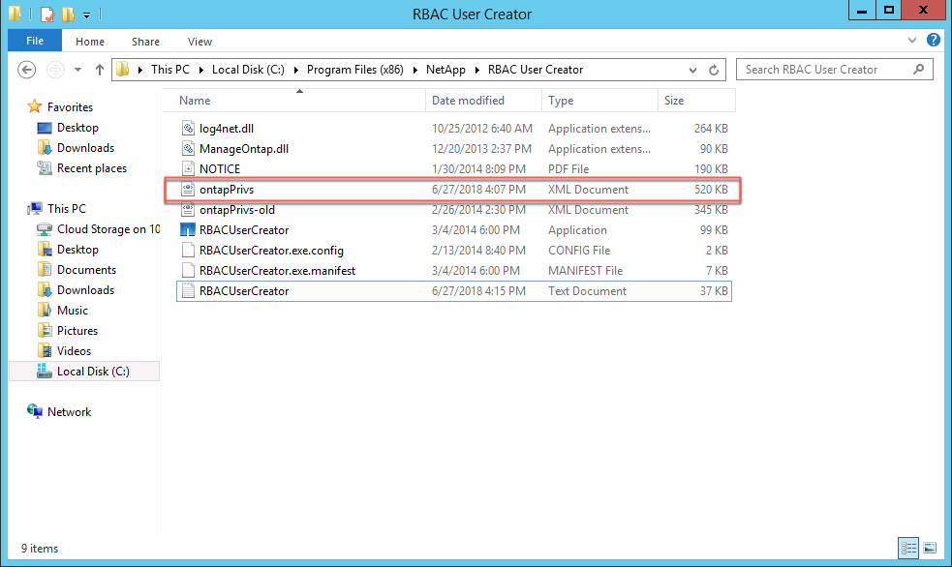

You can start using the RBAC User Creator tool to create new roles and users.

Step 2: Setting up user names and privileges

You can create ONTAP user names with the privileges required for VSC, VASA Provider and SRA.

- Enter the name of the admin user and IP of the storage system for which you want to create the user.
- Click LOGIN. (The tool determines the controller type.)
- 1st Select VSC, VASA Provider and SRA under product, then which Plug-ins you wish to configure under version.
  - If you wish to use only VSC, you must select product version as “VSC 7.x”.
  - If you wish to use VASA Provider along with VSC, then you must select the product version as “VSC and VASA Provider 7.x”.
  - If you wish to use SRA along with VSC, then you must select the product version as “VSC and SRA 7.x”.
  - If you wish to use all three, VSC, VASA Provider and SRA, then you must select the product version as “VSC, VASA Provider and SRA 7.x”.

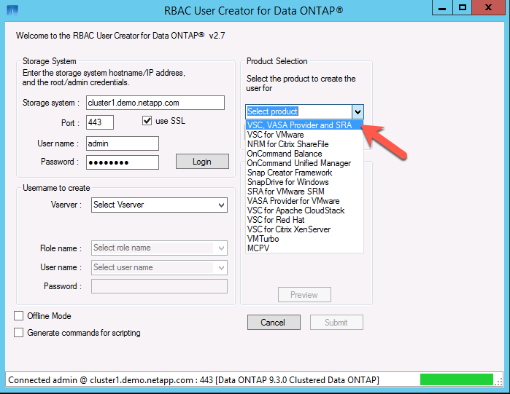
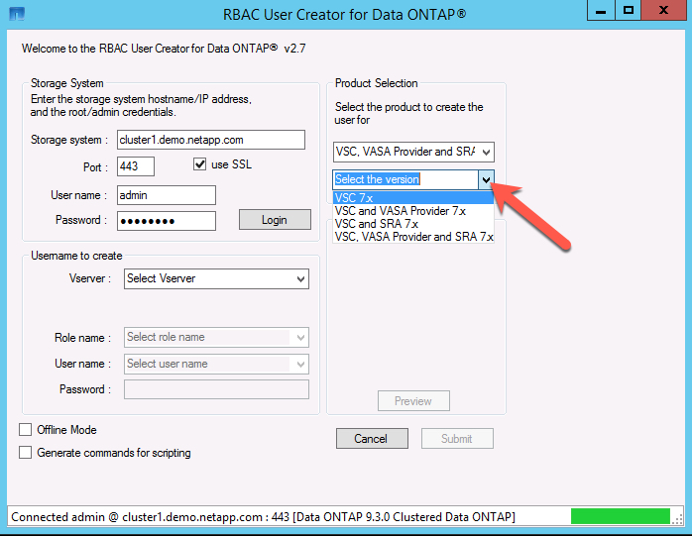

- RBAC User Creator supports creating users on the Cluster-Admin SVM as well as on Data SVMs. Select the appropriate SVM from the drop-down list.
- Select all the ONTAP privilege roles that apply.
  - RBAC User Creator tool merges all the privileges from the selected roles and combines them in a sorted list.
- Enter a name for the role, user, and password, and then click Submit.
  - The role and user name can be new or existing except vsadmin.

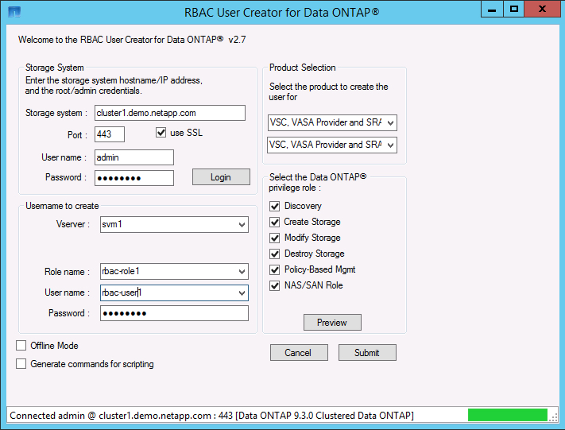
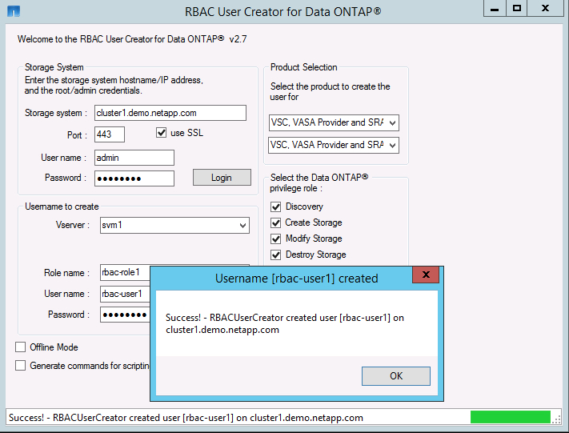

New RBAC User has been created.

Step 3: Adding storage systems

- Log in into your VSC, VASA Provider and SRA plugin from the vCenter.
- Navigate to Storage Systems Tab
- Add or Modify the storage system using the new username and password.

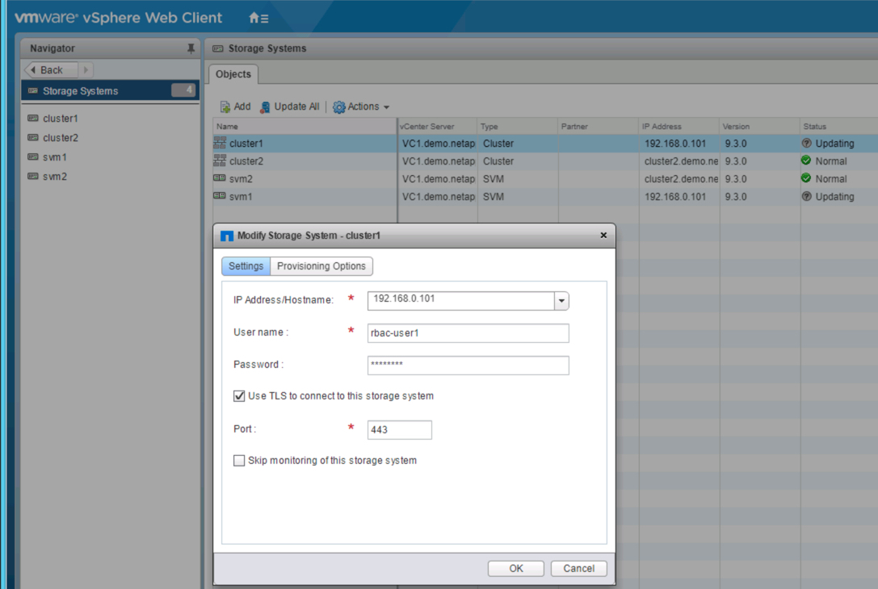

Appendix A: Known issues
- While providing a role name, do not provide any names that begin with “vsadmin”. This will prevent creating any new roles or users.

Appendix B: Resources
- Download RBAC User Creator for ONTAP.
- Download ontapPrivs.xml file.
- Unified Appliance for VSC/VP/SRA 7.X Resource Page

Version History
As an option, use the NetApp Table style to create a Version History table. Do not add a table number or caption.
Version | Date | Document Version History
Version 1.0 | September 2018 | initial release

Refer to the Interoperability Matrix Tool (IMT) on the NetApp Support site to validate that the exact product and feature versions described in this document are supported for your specific environment. The NetApp IMT defines the product components and versions that can be used to construct configurations that are supported by NetApp. Specific results depend on each customer’s installation in accordance with published specifications.
Copyright Information
Copyright © 2018 NetApp, Inc. All rights reserved. Printed in the U.S. No part of this document covered by copyright may be reproduced in any form or by any means—graphic, electronic, or mechanical, including photocopying, recording, taping, or storage in an electronic retrieval system—without prior written permission of the copyright owner.
Software derived from copyrighted NetApp material is subject to the following license and disclaimer:
THIS SOFTWARE IS PROVIDED BY NETAPP “AS IS” AND WITHOUT ANY EXPRESS OR IMPLIED WARRANTIES, INCLUDING, BUT NOT LIMITED TO, THE IMPLIED WARRANTIES OF MERCHANTABILITY AND FITNESS FOR A PARTICULAR PURPOSE, WHICH ARE HEREBY DISCLAIMED. IN NO EVENT SHALL NETAPP BE LIABLE FOR ANY DIRECT, INDIRECT, INCIDENTAL, SPECIAL, EXEMPLARY, OR CONSEQUENTIAL DAMAGES (INCLUDING, BUT NOT LIMITED TO, PROCUREMENT OF SUBSTITUTE GOODS OR SERVICES; LOSS OF USE, DATA, OR PROFITS; OR BUSINESS INTERRUPTION) HOWEVER CAUSED AND ON ANY THEORY OF LIABILITY, WHETHER IN CONTRACT, STRICT LIABILITY, OR TORT (INCLUDING NEGLIGENCE OR OTHERWISE) ARISING IN ANY WAY OUT OF THE USE OF THIS SOFTWARE, EVEN IF ADVISED OF THE POSSIBILITY OF SUCH DAMAGE.
NetApp reserves the right to change any products described herein at any time, and without notice. NetApp assumes no responsibility or liability arising from the use of products described herein, except as expressly agreed to in writing by NetApp. The use or purchase of this product does not convey a license under any patent rights, trademark rights, or any other intellectual property rights of NetApp.
The product described in this manual may be protected by one or more U.S. patents, foreign patents, or pending applications.
RESTRICTED RIGHTS LEGEND: Use, duplication, or disclosure by the government is subject to restrictions as set forth in subparagraph (c)(1)(ii) of the Rights in Technical Data and Computer Software clause at DFARS 252.277-7103 (October 1988) and FAR 52-227-19 (June 1987).
Trademark Information

NETAPP, the NETAPP logo, and the marks listed at http://www.netapp.com/TM are trademarks of NetApp, Inc. Other company and product names may be trademarks of their respective owners.

